|  |  |  |  |  |
| --- | --- | --- | --- | --- |
|  | | **Consumer Research Expert** | | |
| **ConsumerInsight Report** (2020 Travel Report) | | |
| Company | ConsumerInsight | | E-mail | kwonyg@consumerinsight.kr |
| Query | Kwon, Younggyo / Director | | Phone number | 02) 6004-7622 |
| Issued | November 24th (Tuesday), 2020 | | Pages | 3 pages in total |

|  |
| --- |
| **Will the overseas travel explode if COVID 19 is resolved?** |
| * ConsumerInsight looked into changes in consumer sentiments toward travel amid COVID 19 |
| * 4 out of 5 people expected it hard to travel abroad within a year |
| * Overseas travel, polarized into 'aspiring group' vs 'abandoning group' |
| * Potential market demand for women, 20s and university students is growing |
| * Europe as the most preferred travel destination, Japan for travel within a year,   and Hawaii after a year or longer |

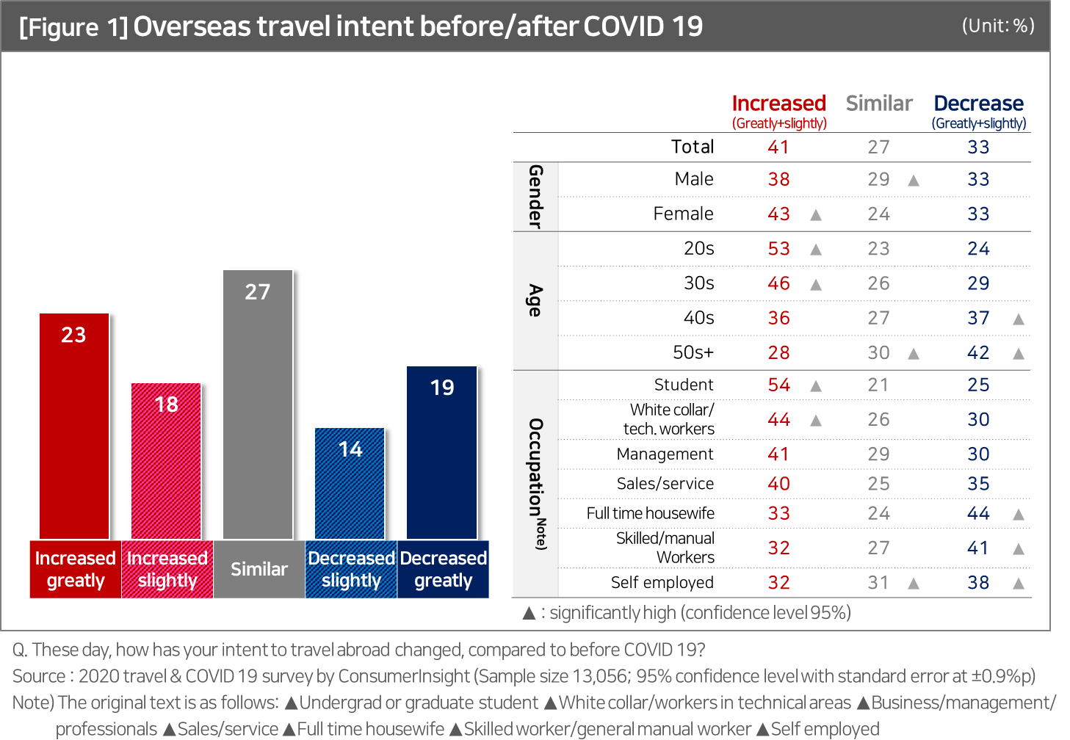

Consumers' desires for overseas travel since COVID 19 are sharply divided. Even if overseas travel resumes, it is likely difficult to go back to life before COVID 19 in a short term. 41% of the people said their desire to travel abroad was greater than before the COVID 19 while some 31% of them responded that their intent on the same decreased,  
indicating that the potential desire for overseas travel is polarizing.

**■ Consumers' desire to travel erupted differently from expected... Likely hard to recover in a short term**Consumer Trend Research Lab at ConsumerInsight, a travel research specialist, conducted 'Travel and COVID 19 Survey' (on 13,056 respondents) and asked respondents how much they would want to travel abroad now, compared to before COVID 19, on 5 point scale.

The result showed ‘similar’ at 27% as the dominant response, followed by ‘increased greatly (23%),’ The response ‘decreased greatly (19%)’ and ‘decreased slightly (18%)’ marked at the later 10% range, with ‘decreased slightly (14%)’ turning out be the lowest [Figure 1]. A general survey result will typically show a single-point distribution with one high value, but this study showed a three-point distribution with two high outliers at the end of the right and left ('increased greatly' and 'decreased greatly'), respectively, next to the mean value. As such, it shows that the intent to travel abroad is extremely divided into a group aspiring overseas travel now made impossible, and another group that nearly has given up the travel. This result is different from the general expectation that if the sky road opens again, the suppressed desire to travel abroad will erupt.

When looked at by the respondent group, the result showed that more than half of university/graduate students (54%) and those in their 20s answered ‘’increased" and a majority of them were females. Female university students in their 20s are the core of the overseas travel aspiration group, followed by 30s (46%), and white collar/workers in technical areas (44%). However, the intent to travel abroad among full-time housewives, skilled/manual workers, and the elderly decreased greatly. These groups of people are relatively more sensitive to COVID19 or more likely to have been exposed to job insecurity and income reduction. Although some groups' thirst for overseas travel will appear as resentful travel consumption, there is a possibility that the number of people who avoid or give up on overseas travel will also increase.

**■ Overseas travel possible “within one year” 23%… “Over 2 years” 38%**

As for the time when overseas travel becomes possible again, 4 out of 10 people (39.4%) cited between 1 and 2 years [Figure 2]. Those who forecast more than two years were similar at 37.9%, and 22.7% of those or 1 out of 5 people predicted the travel would be made possible within one year.

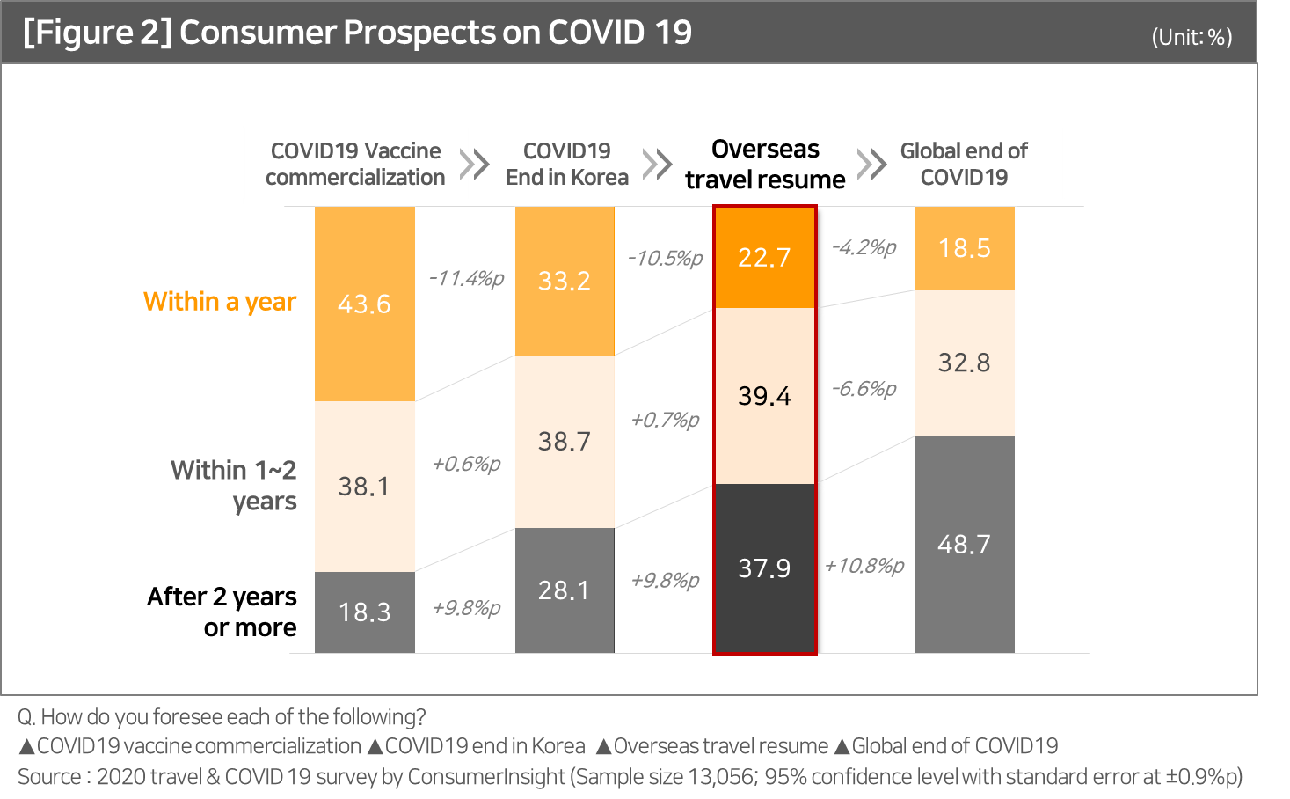

What is worth noting is that there were subtle differences in preferred destinations, depending on when they think the overseas travel would be possible. It is common that Europe, Hawaii, the U.S., Guam, and Japan, which are the existing preferred destinations, ranked at the top, but the more they expected the travel to resume early within one year, the higher their preference was for Japan and Southeast Asia, and Hawaii, Guam and others were rated as the first destinations among those predicting overseas travel as possible after a year [Figure 3].

Considering the fact that it is difficult to end the corona situation in a short period of time in reality, it can be inferred that when the situation is not completely over, a place with a short travel time is preferred, and after COVID19 is over, a remote resort destination is.

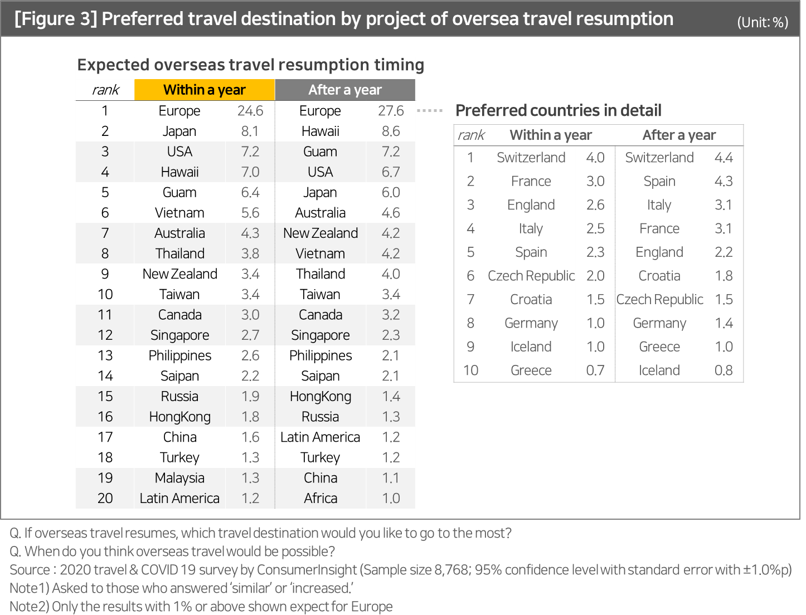

**■ View on overseas travel after the commercialization of the corona vaccine   
and the end of COVID 19 in Korea**

On the other hand, 43.6% of the respondents expected that the Corona vaccine would be commercialized within a year, but 1 out of three respondents (33.2%) foresaw the end of COVID 19, and one out of five people (22.7%) prospected the overseas travel would be possible within a year. [Figure 2]. In other words, 8 out of 10 (77.3%) do not expect overseas travel to be possible within a year. Overseas travel is likely to increase explosively when the time comes, but it is necessary to watch carefully when it will be.

---------------------------------------------------------------------------------------------------------------------------------------------------------

The results are based on 'Travel and COVID 19 Survey' conducted by ConsumerInsight Consumer Trend Research Lab in September 2020. The study surveyed 13,056 people, using IBP (Invitation Based Panel) with more than 800 panelists as a sample frame, and the sampling was done by sex, age, and region proportionally allocated according to national census. The data was collected via email and mobile

---------------------------------------------------------------------------------------------------------------------------------------------------------

Copyright ⓒ Consumer Insight. All rights reserved. No use for commercial purposes allowed.

|  |  |  |
| --- | --- | --- |
| **For-more-Information** | | |
| Kwon, Younggyo / Director | **E.** [kwonyg@consumerinsight.kr](mailto:kwonyg@consumerinsight.kr) | T. 02)6004-7622 |